GRANARD MUNICIPAL DISTRICT

Corporate Affairs,
Aras an Chontae,
LONGFOIRT.

19th July 2016.

Please note time of meeting - 3.30 p.m.

To: Each Member of Granard Municipal District.

Dear Member,

You are requested to attend Meeting of Granard Municipal District to be held in
Granard Community Library on Tuesday, 26th July 2016 at 3.30 p.m. to transact business, as set out on the Agenda hereunder.

Yours sincerely,
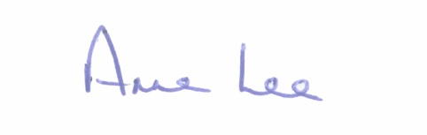

_______________
Anne Lee,
Meetings Administrator.

AGENDA

Prayer before meeting.

1. Confirmation of Minutes of the following Meetings of Granard Municipal District -

- Meeting held on the 24th May 2016.
- Annual Meeting held on the 28th June 2016.
- copies enclosed.

2. Matters arising from Minutes.

3. Area Engineer’s Progress Report.

4. Consideration of applications for the 2016 Community Support Scheme - list attached.

5. Lough Oughter/Lough Erne Joint Drainage Committee.

6. Provision of pedestrian crossing in Ballinalee Village.

7. Notices of Motions submitted by Councillors, as listed hereunder -

Councillor P.J. Reilly.

“I wish to put a motion forward to the meeting for the Council to install Traffic Calming in the village of Lisryan on the Edgeworthstown - Casltepollard Road as you approached the village on each side.

Councillor Michael Carrigy.

“I call on Longford County Council to apply for a Low Cost Safety scheme to provide a safe crossing for pedestrians in Ennybegs Village.”

“ I call on Longford County Council to apply for funding to provide digital speed signs at all schools in the county and give an update on my previous motion re signs at school bus pick up locations.”

Councillors Michael Carrigy, John Duffy and Pauric Brady.

“I call on Longford County Council to provide funding to the Granard Municipal District to install new footpaths at various locations in the District.”

8. A.O.B.

